North East Lincolnshire Multi-Agency
Strategy Meeting Guidance
2023

Strategy Meeting Guidance Document
Prior to the strategy discussion the following steps considerations need to be undertaken. Please refer to the Humber Wide Integrated Partnership Practice Standards, which makes explicit the process, including how to make a referral and the expectations of agencies.

Index
The hyperlinks below will direct you to the relevant section as to how they should be completed.
This document provides details as to what should be recorded in the relevant sections, but also what is essential to meet the agreed professional standards for all four local authority areas.
Page(s) | Section(s)
2 - 6 | Humber wide integrated Partnership Practice standards | Assessing need and providing early help  Making a referral  - Consent  - Quality standard  - Previous significant history  - Timeliness
6 - 7 | Assessment of Need | Social workers should  The Police should  All agencies should
7 - 12 | Strategy Discussions | The Purpose of a strategy discussion  Quality of standards  - Social workers should  - Health practitioners should  - The police should  Outcome of S47
13 - 18 | How to complete the strategy meeting document | Details as to which Local Authority and specific team is holding the strategy meeting, Date and Time and the recording of Professionals attendance
19 – 20 |  | Alleged category of abuse and the circumstances of the concern
20 - 24 |  | Details of people and how they should be recorded relevant to the strategy meeting
25 - 27 |  | Consent
27 - 31 |  | Discussion – How this should be structured and what information is required
32 - 35 |  | Decision Outcome and escalation
36 – 40 |  | Initial Investigation & Safeguarding plans
40 - 43 |  | Information sharing – What can or cannot be shared to the child and/ or family
43 - 45 |  | Priority Actions
46 | Flow Chart – Action following a strategy discussion

HUMBER WIDE INTEGRATED PARTNERSHIP PRACTICE STANDARDS

The purpose of the following practice standards is to ensure a consistent approach to best practice in line with working Together 2018 across the 4 Local Authorities and Humberside Police.

All 4 Local Authorities alongside Humberside Police have had the opportunity to contribute to the development of the practice standards.

ASSESSING NEED AND PROVIDING EARLY HELP
Effective early help relies upon local organisations and agencies working together to:
• identify children and families who would benefit from early help
• undertake an assessment of the need for early help
• provide targeted early help services to address the assessed needs of a child

MAKING A REFERRAL

- Anyone who has concerns about a child’s welfare should make a referral to local authority children’s social care in line with the threshold/ Levels of Need document.
- This should be done immediately if there is a concern that the child is suffering significant harm or is likely to do so. This includes both within and outside office hours.
- Where there is not a concern that a child may be at risk of significant harm, the referral should be made as soon as possible within 1 working day.

Consent

- Should be gained by the referrer to make the referral wherever possible. The Data Protection Act 2018 and General Data Protection Regulations (GDPR) enable the sharing of information for the purposes of keeping children safe.
- Where the child expresses a wish for his or her parents not to be informed, their views should be taken seriously and a judgement made based on the child’s age and understanding, as to whether the child’s wishes should be followed. The reason around this should be clearly recorded.
- When a referral is received, the Social worker should, gain further consent from the parents or carers of the child for the child’s views to be gained and for further checks and information to be shared with other agencies, unless contacting parents at this stage may negatively impact on the child, or increase safeguarding concerns.
- The 7 Golden rules of information sharing should be used to inform decision making regarding sharing information in the best interests of a child. Partner agencies ensure that the information shared is necessary, proportionate, relevant, adequate, accurate, timely and secure. The child’s safety and welfare must be the paramount consideration in making any decision. Enough clear information needs to be gathered to enable a judgement on the child’s best interests to be formed. Where a decision is taken to override the need for consent, the rational for this should be clearly recorded.
- Concerns must not be discussed with parents/carers before making a referral where:
- Discussion would put a child at risk of significant harm.
- Discussion would impede a Police investigation or social work enquiry.
- Abuse is suspected and parents are reported to be the perpetrator.
- Organised or multiple abuse is suspected.
- Fictitious illness or induced illness is suspected.
- Contact with the parents/carers would place you or others at risk
- It is not possible to contact parents/carers without causing undue delay in making the referral

Quality standard

The quality standards expected to be considered and where appropriate clearly recorded within a referral are:
- Name, address, dates of birth and basic details of all children being referred
- The date and time of the referral and the full details of the referrer.
- The specific concerns being referred and the impact of the concerns on the child’s welfare and protection.
- How the child’s immediate safety has been ensured should be explicitly recorded alongside further actions required.
- The family structure. This should (where appropriate) include siblings, half siblings, both parents and/or carers, any step parents, grandparents and significant others.
- Whether consent has been gained for the referral to be made and further information to be shared and if not the rational for this.
- Cultural and diversity considerations
- Summary and analysis of the previous history.
- The views of the child where possible.
- The views of parents and/or carers.
- The views of partner agencies (including the professional who knows the child best/ lead).
- Evidence of offers of early help / early help plans and assessments
- Appropriate information shared from other agencies
- Analysis of the risks and protective factors to inform recommendations
- Written follow up by the referrer

Previous significant history

It is important to review all relevant IT systems for the subject child and any siblings, parents and any significant others to ascertain whether there is any significant history that requires consideration or risks from any adults. The previous significant history should be summarised and analysed by the worker taking the referral in order to enhance the overall decision making.
- If the referrer is a professional, they should be asked to follow up their referral in writing within 24 hours, as per the requirements arising from the Victoria Climbie inquiry (an e-mail is acceptable, which should be saved within the child’s electronic file.

Timeliness

Within 24 hours of the contact/referral being received the Children Services Front Door Team should acknowledge receipt of referral and make a decision about the next steps required. This will include determining whether:
- The child requires immediate protection and urgent action is required
- The child is in need and should be assessed under section 17 of the Children Act 1989
- There is reasonable cause to suspect that the child is suffering or likely to suffer significant harm, and a strategy discussion is required
- The child and family could be supported without the need of statutory intervention. If support is required at a targeted and universal level, this is to be agreed with the lead professional.

Return to the index page

Assessment of Need

A social worker should:

- Lead on the assessment and complete this within 45 working days of the referral being received.
- See the child within the appropriate timescales according to the level of need
- Conduct interviews with the child and family members, together and alone as appropriate in a way that minimises distress and maximises the accurate information and holistic understanding of the lived experiences

The Police should:

- Assist the social worker and other agencies to undertake the assessment through timely and quality information sharing –
- If a crime has been committed, the police should be informed by the social worker
- Inform the social worker if a child’s welfare is impacted upon by criminal act

All agencies should:

- be involved in the assessment and provide further information about the child and family
- agree further action including what services would help the child and family and inform local authority children’s social care if any immediate action is required

Return to the index page

STRATEGY DISCUSSION

Whenever there is reasonable cause to suspect that a child is suffering or is likely to suffer significant harm there should be a strategy discussion led by the local authority children’s social care and including the police, health and any other relevant agency including the referrer. The social worker and partner agencies should have suitable experience and decision-making abilities to contribute effectively to the meeting and outcome for the child.
A strategy discussion should be arranged at a suitable timeframe to meet the child’s needs, immediately if necessary. This should also take into consideration that the relevant agencies are invited to the strategy meeting and must not be held without them, unless in exceptional circumstances. Furthermore, each agency should be provided with the relevant amount of time to be able to conduct the correct research for the strategy meetings to be able to provide the relevant information to improve decision making and provide the best investigation and safeguarding plan for the child and family. This may entail delaying the strategy discussion to allow this to provide the best outcome, however, in the meantime safeguarding measures for that child should be implemented where necessary to remove any further risk until the strategy meeting has been convened.
Any agency receiving information that a child is suffering or likely to suffer significant harm should share this information immediately with the Social worker (both within and outside normal working hours) without delay so that a strategy discussion can be convened.
such as the referring agency.
A strategy discussion might take the form of a multi-agency meeting or phone calls and more than one discussion may be necessary. A strategy discussion can take place following a referral or at any other time, including during the assessment process and when new information is received on an already open case.
Best practice would be for a face-to-face meeting to be held in complex child abuse situations which includes multiple children.

The purpose of a strategy discussion is to:

- Confirm jointly whether an enquiry is required under Section 47 of the children Act 1989.
- Agree what action is required immediately to safeguard and promote the welfare of the child.
- Agree and set a clear investigation plan and where appropriate consider the need for medical treatment or examination and a DVD interview in line with achieving best evidence.
- Plan how the child subject to the investigation is going to be interviewed, how they are going to be seen alone where appropriate and who is going to take the lead role in the interview.
- Determine whether it is necessary to speak to the child without gaining parental consent. Parental consent will always be sought unless to do so may place the child at increased risk of harm.
- Consider whether other siblings who may be affected may need assessment in their own right
- Determine how the purpose and outcome of a S47 enquiry is to be explained to the parents, carers and child having regards for understanding and diversity issues.
- Considering race, ethnicity, and diversity issues (e.g., any disability) decide whether an interpreter or worker with any other specialist communication skills may be required. This may include consideration of the use of an intermediary.
- Determine if planned or urgent legal action is required.
- To agree whether there is a requirement for a criminal investigation to run alongside the enquiries relating to the child.

Quality Standards

- The Local authority children’s social care should convene a strategy discussion to determine the child’s welfare and plan rapid future action if there is reasonable cause to suspect the child is suffering or is likely to suffer significant harm. This includes where a child has been made subject to Emergency Protection Order or Police utilising their Powers of Protection.
- A local authority social worker, health practitioners, school/ education provision and a police representative should, as a minimum, be involved in the strategy discussion. Other relevant practitioners will depend on the nature of the individual case
- Wherever possible, the professional with direct knowledge of the child and family should contribute
- All attendees should be sufficiently senior to make decisions on behalf of their organisation and agencies.
- The discussion can be a physical meeting, a virtual meeting or a series of phone calls where appropriate information is shared to inform the decision. This also includes liaising with Health, Police and Education prior to convening a strategy discussion to determine whether the threshold is met to suspect the child is suffering or likely to suffer significant harm.
- Minutes and actions recorded with who is responsible for completing these and timescales should be completed. A copy of the action log should be given to all attendees within 24 hours of the discussion and a full copy of the minutes should be shared within 10 working days.
- Wherever a strategy discussion is required to be held outside office hours, the full information from all partners should be gained on the next working day
- A section 47 enquiry is carried out by undertaking or continuing with an assessment in accordance with the principles and parameters of a good assessment.
- Social workers should lead assessments under section 47 of the Children Act 1989. The police, health practitioners, teachers and school staff and other relevant practitioners should help the local authority in undertaking its enquiries.

Social workers should:

- Provide appropriate and proportionate information regarding the child and family’s social care and an analysis of what this means within the current context to inform decision making.
- Determine, based on the information shared within the meeting, whether a section 47 investigation is required and whether this should be joint with the police or single agency.
- Ensure the strategy discussion considers the child’s welfare and safety and identifies the level of risk faced by the child.
- Decide what information should be shared with the child and family (on the basis that information is not shared if this may jeopardise a police investigation or place the child at risk of significant harm)
- Consider what further action is required, and who will do what by when, where an EPO is in place, or the child is the subject of police powers of protection
- Agree with partners whether ABE is required, the rational, who will complete this and the timing
- Agree with partners whether a medical examination is required, the rational, who will complete this and the timing

Health practitioners should:

- Provide appropriate and proportionate information regarding the child and family’s health and an analysis of what this means within the current context to inform decision making.
- Advise about the appropriateness or otherwise of medical assessments and explain the benefits that arise from assessing previously unmanaged health matters that may be further evidence of neglect or maltreatment.
- Provide, co-ordinate, analyse and share any specific information from relevant practitioners regarding family health, maternity health, school health mental health, domestic abuse and violence and substance misuse to assist strategy and decision making.
- Secure additional expert advice and support from named and/or designated professionals for more complex cases following preliminary strategy discussions
- Undertake appropriate examinations or observations, and further investigations or tests, to determine how the child’s health or development may be impaired

The police should:

- Provide appropriate and proportionate police information, including previous crimes, ongoing investigations and relevant intelligence regarding the child, parents, stepparents and any relevant others and an analysis of what this means within the current context to inform decision making.
- Provide appropriate and proportionate police information, including previous crime, ongoing investigations and relevant intelligence regarding risks outside of the family home.
- Discuss the basis for any criminal investigation and any relevant processes that other organisations and agencies might need to know about, including the timing and methods of evidence gathering.
- Lead the criminal investigation (local authority children’s social care has the lead for the section 47 enquires and assessment of the child’s welfare) where joint enquiries take place

OUTCOME OF S47

The Assessment will be completed as part of the s47 enquiry which will consider the outcomes for the child and the further support which may be required. The assessment may conclude that:
- Significant harm is substantiated, the child is at ongoing risk of significant harm and an initial Child protection conference should be convened.
- Significant harm is substantiated, the child is at ongoing risk of significant harm and legal advice is to be sought.
- Significant harm was substantiated but the child is not at ongoing risk of significant harm, but the child is in need and a CIN plan should be implemented
- Significant harm is not substantiated, and the child is not at ongoing risk of significant harm, but the child is in need and a CIN plan should be implemented
- Significant harm is not substantiated but the child has additional needs and early help is required
- Significant harm is not substantiated, and no further action is required.
- The outcome of the assessment should be shared with partners who contributed to the strategy discussion or who have an ongoing role of in the child’s plan within 5 working days of completion
- The outcome of police investigations should be shared with the social worker or lead professional to consider within future planning within 5 working days.
- Update CSC with key the outcome of any criminal investigation to enable records to be updated and to enable ongoing risk assessment and review of safeguarding plans
- If an early help plan is recommended, the further actions, with timescales should be agreed with the lead professional.

Return to the index page

How to complete the strategy meeting document

Details as to which Local Authority and specific team is holding the strategy meeting

The first section is in relation to ascertaining if this is an urgent strategy meeting, out of hours and/ or which team requested the strategy meeting and which local authority.
Police Ref No | Urgent strategy meeting held | Area & Team NEL ☐ | Area & Team  NL ☐ | Area & Team  ER ☐ | Area & Team  Hull ☐ | Out of hours | Police Team & Area ☐
 | Yes ☐ No ☐ | Choose an item. | Choose an item. | Choose an item. | Choose an item. | Yes ☐ No ☐ | Choose an item.

Please complete the sections by ticking the relevant box and utilising the drop-down selectors (Choose an item) under each local authority area to identify the team requesting.
The Police Ref No relates to the Connect/ Niche record that this strategy meeting relates to
Example - NL box ticked, and the Drop down used and the relevant Police team in the strategy meeting.
Police Ref No | Urgent strategy meeting held | Area & Team NEL ☐ | Area & Team  NL ☒ | Area & Team  ER ☐ | Area & Team  Hull ☐ | Out of hours | Police Team & Area ☒
 | Yes ☐ No ☐ | Choose an item. | IMAP | Choose an item. | Choose an item. | Yes ☐ No ☐ | Vul Hub

This next section is to ensure the date, time and how the meeting was held is recorded effectively.
Date of Discussion | Time of Discussion | How was the discussion held
Click here to enter a date. | Start:  Finish: | By Phone ☐ In Person ☐ Virtually ☐

For date of the discuss click into the area that states ‘Click here to enter date’ this will highlight a little black triangle to the right (as per the below image). Click on that and it open up a calendar. At the bottom of the calendar is a grey button which states ‘Today’ Click that, and it will add that day’s date.
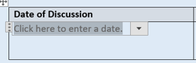
For the start times just enter the time the Strategy meetings starts next to the start time and enter the time the strategy meeting finishes next to finish.
In relation to how the strategy meeting was held please place your cursor over the relevant box and right click your mouse

An example of how this would look is as below.
Date of Discussion | Time of Discussion | How was the discussion held
04/11/2021 | Start: 12:30  Finish: 13:00 | By Phone ☐ In Person ☐ Virtually ☒

This next section is in relation to ensuring the people present are recorded properly with the professional’s full details including their Role, Full Name, Job Title and email address.
Persons Present
Role | Name | Job Title | Contact Details (email address)
Chair | Click or tap here to enter text. | Click or tap here to enter text. | Click or tap here to enter text.
CSC | Click or tap here to enter text. | Click or tap here to enter text. | Click or tap here to enter text.
Police | Click or tap here to enter text. | Click or tap here to enter text. | Click or tap here to enter text.
Health | Click or tap here to enter text. | Click or tap here to enter text. | Click or tap here to enter text.

This section initially covers the statutory partners that legislations states should be the minimum requirement to hold a strategy meeting. However more boxes can be opened by clicking in the text box at the showing ‘click here to enter text’ and this will add a small plus sign at the end:
Click on the + sign and this will open another box to add other partners such as Education i.e.
As these strategy meetings are being held on Teams and the document is being shared then to assist the minute taker and completion of the document it is requested that the professional attending the strategy meeting Utilises the comments section and types in their role, Full Name, Job title and email address as per the below.

At the top of the Teams meeting is a speech bubble and if you click on that it opens meeting chat to the right of the screen

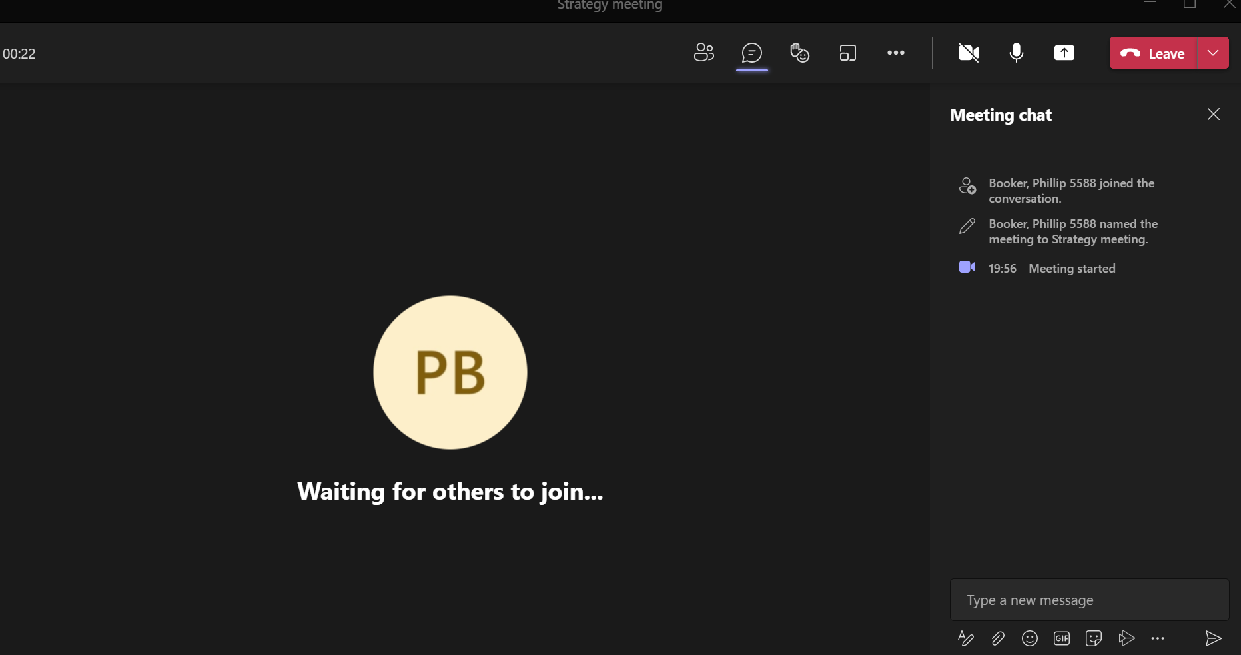

To add your details start writing your Role, Name, Job Title and email address in the text box at the bottom right of the screen which states, ‘Type a new message’ It is imperative that the full details are added without pressing enter, but just adding the – symbol in between the ‘Role – Name – Job Title – Email address’ as this will keep that professionals’ details as one entry as per the below:
This will make it easier for the minute taker to collate all the attending professionals’ details to effectively cut and paste them into the relevant sections on the document. This will save time whilst also ensuring names and contact details are spelt correctly.

Apologies
This section is virtually the same as the persons present section and is essential to ensure invited parties who could not attend are documented, with a clear reason as to why they could not attend:
Apologies
Role | Name | Job Title | Email Address | Reason for not attending
Click here to enter text. | Click here to enter text. | Click here to enter text. | Click here to enter text. | Click here to enter text.

Again, to add more boxes if there are multiply professionals that could not attend click in the last box where it states, ‘Click here to enter text’ this will create a + sign. Click on the plus sign and it will open another box.
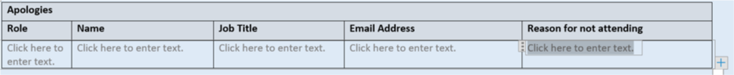
An example of how this will look would be as follows:
Apologies
Role | Name | Job Title | Email Address | Reason for not attending
YOS | Joanne Bloggs | YOS Case officer | Joanne.Bloggs@northlincs.gov.uk | Currently in another strategy meeting
Click here to enter text. | Click here to enter text. | Click here to enter text. | Click here to enter text. | Click here to enter text.

Return to the index page

Alleged Category of abuse

To complete this section, it is required that the relevant box be selected and then the drop-down box to select the most relevant type of abuse. Please see the below example in relation to Risk outside the home for Child Criminal Exploitation. Where there is a secondary concern for the child, then please utilise the section – Secondary Concern if there is no secondary do not complete.

Alleged Category of Abuse
Primary Concern | Secondary Concern
Risk Inside The Home (RITH) ☐  Click on the down arrow to choose  Risk Outside The Home (ROTH) ☒  CCE  Missing from home ☐  Click on the down arrow to choose | Risk Inside The Home (RITH) ☐  Click on the down arrow to choose  Risk Outside The Home (ROTH) ☐  Click on the down arrow to choose  Missing from home ☐  Click on the down arrow to choose
Concern and circumstances that relates to the alleged abuse
This section must be clear and concise and not a cut and paste from a Police Log or Partner agency case system, that has other information that is not relevant. This is due to the fact that this can confuse matters with irrelevant information.
Concern and circumstances that relates to the abuse

Return to the index page

Subject(s) of the strategy meeting
The first section is in relation to the child(ren) that the strategy meeting is being requested for as per the below example by clicking in the relevant text boxes:
Forename | Middle name | Surname | Date of Birth | Gender | Ethnicity | Ref No/ ID | Address
Neve | Olivia | BLOGGS | 10/09/2014 | Male | White - English, Welsh, Scottish, Northern Irish or British | 2839/12 | 21 Church lane. Hull, HU7 1AB

Please complete the sections as per the format above ensuring the date of birth is DD/MM/YYYY. In relation to the address please ensure the full address is included with the post code.
The Ref No – This is the assigned reference number that Children Social Care has on their system for that individual(s).
To add another person and create a new box when you type in the last section in this case Address you will see a small + sign occur as per the below:

If you click on the + sign with your mouse it will create another box to complete as per the below
Forename | Middle name | Surname | Date of Birth | Gender | Ethnicity | Ref No/ ID | Address
John | Paul | BLOGGS | 10/09/2014 | Male | White - English, Welsh, Scottish, Northern Irish or British | 2839/12 | 21 Church lane. Hull, HU7 1AB
Click here to enter text. | Click here to enter text. | Click here to enter text. | Click here to enter text. | Please click here | Choose an item. | Click here to enter text. | Click here to enter text.

Sibling(s) and/or other relevant children:
This section covers whether there are any siblings or other relevant children linked to the subject of the strategy meeting to be considered that need discussing. However, some siblings or relevant children may not be relevant to be discussed in the strategy meeting:
The first two questions to cover are as follows:
They do not have any siblings and/or other relevant children to discuss ☐
They do have siblings and/or other relevant children, but they are not relevant for this discussion ☐

If any of the above categories are appropriate, then hover the cursor over the square and click the mouse and do not complete the next box which asks for sibling or other relevant child details.

Forename | Middle name | Surname | Date of Birth | Gender | Ethnicity | LA Ref No/ ID | Address
Click here to enter text. | Click here to enter text. | Click here to enter text. | Click here to enter a date. | Please click here | Choose an item. | Click here to enter text. | Click here to enter text.

If this section needs completing, then follow the guidance as above for subject(s) of the strategy meeting.

Person(s) posing a risk
This is in relation to a child or adult that poses a risk to the subject(s) of the strategy meeting by completing all of the relevant sections as per the below example:
Forename | Middle names | Surname | Date of Birth | Gender | Ethnicity | LA Ref No/ ID | Address
Ronald | James | McDonald | 12/09/1978 | Male | White - English, Welsh, Scottish, Northern Irish or British | 1234 | 123 Church lane, Sandford, Sandfordshire HU125TH
Relationship to the child |  | Child Minder
Forename | Middle names | Surname | Date of Birth | Gender | Ethnicity | LA Ref No/ ID | Address
Click here to enter text. | Click here to enter text. | Click here to enter text. | Click or tap here to enter text. | M/F | Choose an item. | Click here to enter text. | Click here to enter text.
Relationship to the child |  | Choose an item.

It is also key that the relationship to the child is ascertained by clicking on the ‘choose an item’ which will provide a list of relationships as per the below: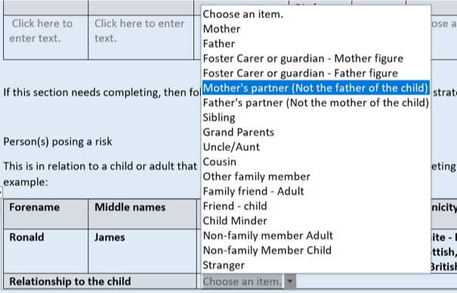
If there is more than one person that poses a risk. Utilise the + sign which will appear when you click in to the ‘Choose an item’ box for relationship to the child. This will create a new box as per the below:
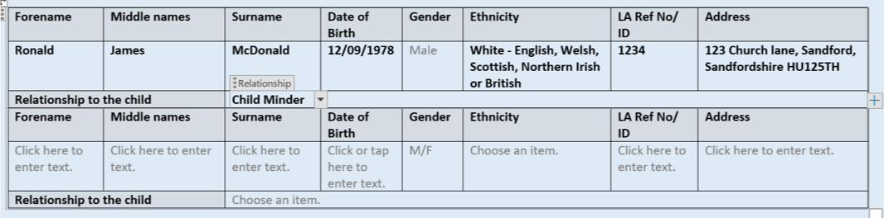
Parent(s)/ Guardian(s)
This section is to ensure that the full details of the parent(s) or Guardian(s) are recoded properly for the child subject to the strategy meeting as per the below:
Forename | Middle names | Surname | Date of Birth | Gender | Ethnicity | LA Ref No/ ID | Address
Click here to enter text. | Click here to enter text. | Click here to enter text. | Click here to enter a date. | Please click here | Choose an item. | Click here to enter text. | Click here to enter text.
Relationship to the child |  | Choose an item.
Forename | Middle names | Surname | Date of Birth | Gender | Ethnicity | LA Ref No/ ID | Address
Click here to enter text. | Click here to enter text. | Click here to enter text. | Click here to enter a date. | M/F | Choose an item. | Click here to enter text. | Click here to enter text.
Relationship to the child |  | Choose an item.

If there is more than one parent or guardian, utilise the + sign which will appear when you click in to the ‘Choose an item’ box for relationship to the child. This will create a new box as per the below:
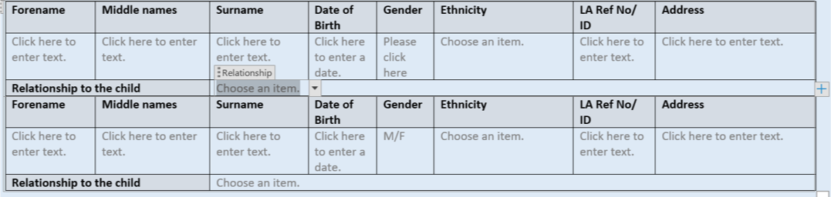
Return to the index page

CONSENT

Obtaining consent from someone able to do so should always be the starting point. However, there is a legal framework for overriding consent to share information for safeguarding purposes at both statutory intervention and early intervention and prevention following circumstances around that Universal and Early help level of need are covered by:
- Public Interest Test
- Human Rights Act – Articles 2, 3 & 8
- Common Law
- Police Intelligence – There is a legal requirement to protect the source of the intelligence (See appendix A for Intelligence handling codes)
- ‘Legitimate Purpose’

Where it is necessary to share information about a child, adult or family there are many pieces of legislation in England and Wales that provide legal justification. In respect of safeguarding and promoting welfare of children, the relevant act of Parliament are:
- The Data Protection Act (2018)
- The Children Act (1989)
- The Children Act 2004 (as amended by the Social Work Act 2017)

Due to this it is essential to ensure that the authorisation, reason and rationale is documented as to why these checks can be completed. There are two parts to this section on the form which covers consent obtained as per below:

First part relates to where consent has been obtained and the main details required are:
- Full name of who has provided the consent
- Their relationship to the child

An example of how that would look is as per the below section
Consent
Consent Obtained: Yes ☒ No ☐ (If the No please go to the next section)

If yes, details of who consent was provided by and their relationship to the child(ren):

Forename | Middle name(s) | Surname | Relationship to the child
Jayne | Lucy | Bloggs | Mother

Second part relates to where consent has not been obtained and as to whether the consent has been overridden and if so, what the rationale is. The key aspects in relation to this are as follows:
- Is there a statutory requirement that provides the authority to override consent such as Child Protection (Level 4 Acute/ Specialist, Including Safeguarding)
- If it in relation to safeguarding that meets the statutory threshold, then select the relevant criteria that will be found in the section below which states ‘Click on the down arrow to choose

Has consent been overridden for a statutory requirement (Child Protection) – Yes ☐ No ☐

If YES, please select the relevant criteria under the statutory requirement | If NO, please provide clear rationale as to why consent is being overridden
Click on the down arrow to choose | Click here to enter text.

This will provide a list as follows:
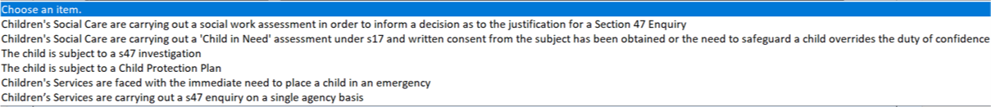

If consent has not been obtained and it does not meet the threshold, then there needs to be a clear rationale as to why consent is being overridden or that a strategy meeting should not be held as it does not meet the criteria. This should be completed under the section which has NO clearly identified.
Return to the index page

Discussion
This is one of the key areas in relation to strategy meeting to identifying the concerns with relevant information to assist the decision makers in the meeting to ascertain if the circumstances meet the threshold of need and what the significant harm is in relation to. This is an area of the strategy meeting that can become confusing, where structure is lost, numerous people are discussed in one go by a particular agency, rather than being specific for that individual. It has also been ascertained that information is being shared that is not relevant, which can detract from the key concerns trying to be identified.
To assist, the following structure should be followed to keep the focus on the concern to ascertain whether or not the threshold is met.
Discussion
The discussion be simplified to discuss one relevant person at a time with each agency, before they move on to the next relevant person, For example there are 2 children to discuss and an adult that poses a risk.

Child A

Each agency should summarise what relevant information they hold for the alleged category of abuse for Child A, and refrain from talking about Child B and the adult that poses a risk at this time. This would look like:
CSC providing relevant information about Child A
Police providing relevant information about Child A
Health providing relevant information about Child A
Education etc.

The next stage will be to do exactly the same for Child B

Child B

Each agency should summarise what relevant information they hold for the alleged category of abuse for Child B, and refrain from talking about Child A and the adult that poses a risk at this time. This would look like:
CSC providing relevant information about Child B
Police providing relevant information about Child B
Health providing relevant information about Child B
Education etc.

The next stage will be to do exactly the same for Adult posing a risk.

Adult Posing a Risk

Each agency should summarise what relevant information they hold for the alleged category of abuse for Adult Posing a risk, and refrain from talking about Child A and Child B at this time. This would look like:
CSC providing relevant information about Adult Posing a risk
Police providing relevant information about Adult Posing a risk
Health providing relevant information about Adult Posing a risk
Education etc.

The above should also take into account diversity, equality and inclusion and cover key concerns that each agency has for the individual being discussed.

To assist in keeping the information relevant and concise would be for each agency to write a summary of the information they are sharing for each person and add to the meeting chat section of teams as per the below.

Threshold and Significant harm

This is a key part of the discussion to record whether the threshold has been met from the above information and what the significant harm is to make sure this is clearly recorded which provides the rationale for the decision.

Key areas to consider in relation to significant harm are as follows:

Level 4 – Acute/ Specialist, Including Safeguarding

These are children who have experienced significant harm or who are at risk of significant harm (Section 47) and includes children who have significant welfare concerns (section 17) A single assessment co-ordinated by a social worker is required to determine the level of support/ intervention.

Significant Risk of Harm

Strategy Discussions - when should they take place (Working together 2018)

Whenever there is reasonable cause to suspect that a child is suffering, or is likely to suffer, significant harm where there should be a strategy discussion involving local authority children's social care, the police, health and other bodies such as the referring agency. This may take the form of a multi-agency meeting or phone calls and more than one discussion may be necessary. A strategy discussion can take place following a referral or at any other time, including during the assessment process.

The Children Act 1989 introduced Significant Harm as the threshold that justifies compulsory intervention in family life in the best interests of children.
Physical Abuse, Sexual Abuse, Emotional Abuse and Neglect are all categories of Significant Harm.

Harm is defined as the ill treatment or impairment of health and development. This definition was clarified in section 120 of the Adoption and Children Act 2002 (implemented on 31 January 2005) so that it may include, "for example, impairment suffered from seeing or hearing the ill treatment of another".

Suspicions or allegations that a child is suffering or likely to suffer Significant Harm should result in an Assessment incorporating a Section 47 Enquiry
There are no absolute criteria on which to rely when judging what constitutes significant harm. Sometimes a single violent episode may constitute significant harm but more often it is an accumulation of significant events, both acute and longstanding, which interrupt, damage or change the child's development.

Consideration of the severity of ill-treatment may include:

- The degree and extent of physical harm.
- The duration and frequency of abuse or neglect.
- The extent of premeditation,
- The degree of threats and coercion,
- Evidence of sadism, and bizarre or unusual elements in child sexual abuse.

When judging what constitutes Significant Harm it is necessary to consider:

- The family context, including the family's strengths and supports,
- The child's development within the context of the family and within the context of the wider social and cultural environment,
- Any special needs, such as a medical condition, communication difficulty or disability that may affect the child's development and care within the family,
- The nature of harm in terms of the ill-treatment or failure to provide adequate care,
- The impact on the child's health and development,
- The adequacy of parental care.

A number of factors may give rise to suspicion about the cause of an injury, the most obvious being a statement by the child and/or another person that the injury has been caused deliberately or not accidentally.

The following guidance is intended to help all professionals who come into contact with children. It should not be used as a comprehensive guide, nor does the presence of one or more factors prove that a child has been abused, but it may however indicate that further enquiries should be made. The following factors should be taken into account when assessing risks to a child. This is not an exhaustive list.

Professionals should be alert to situations where a child is injured and:

- The explanation provided by the parent or carer is apparently incompatible with the physical injury,
- There are conflicting or different explanations provided,
- There is no explanation provided or a lack of awareness of how the injury occurred,
- There is a reluctance on the part of the parent or carer to provide information about the current or previous injuries,
- There is a reluctance to agree to medical assessment,
- There is a delay or failure to seek appropriate medical attention for an injury,
- There are frequent minor injuries or presentations of the child at Accident and Emergency Departments,
- The parent or carer is impatient, angry or aggressive towards the child,
- The parent or carer is under the influence of alcohol or another substance,
- A child reacting in a way that is inappropriate to his/her age or development,
- The parent indicates difficulties in coping with the child,
- There is evidence of domestic abuse or parental mental ill health.

Many families are disadvantaged and lack a wage earner. Poverty may mean that children live in crowded or unsuitable accommodation, have poor diets, health problems or disability, are vulnerable to accidents, and lack ready access to good educational and leisure opportunities.

Racism and racial harassment are additional sources of stress for some families and children. Although racism causes Significant Harm it is not, in itself, a category of child abuse. The experience of racism is likely to affect the responses of the child and family to assessment and enquiry processes. Failure to consider the effects of racism will undermine efforts to protect children from other forms of significant harm.

Other sources of stress for children and families referred to in more detail in this Manual include:

- Domestic Violence (see Domestic Violence and Abuse Procedure);
- Drug and Alcohol Misuse (see Children of Drug/Alcohol Misusing Parents Procedure);
- Mental Illness (see Mental Illness of a Parent or Carer Procedure).

Return to the index page

Decision Outcome

This section is essential to clearly identify the decision of the strategy meeting. This can be documented and clearly audited by selecting the drop-down box under Decision outcome. Due to the fact that numerous children can be discussed in the strategy meeting and there may be different outcomes for the different children then this needs to be recorded.
Due to this and to make it clear, how many children were discussed that were relevant to the strategy meeting, please select the relevant check box reflecting the number of children. i.e., 3 children discussed select box No. 3
Decision Outcome – Number of Children discussed for decision making - 1 ☐ 2 ☐ 3 ☒ 4 ☐ 5 ☐ 6 ☐
Name: | Name: | Name: | Name: | Name: | Name:
Choose an item. | Choose an item. | Choose an item. | Choose an item. | Choose an item. | Choose an item.

To identify the result for each of the three children please add their first name in the title box, as per the below i.e., Rita, Bob and Sue
Decision Outcome – Number of Children discussed for decision making - 1 ☐ 2 ☐ 3 ☒ 4 ☐ 5 ☐ 6 ☐
Name: Rita | Name: Bob | Name: Sue | Name: | Name: | Name:
Choose an item. | Choose an item. | Choose an item. | Choose an item. | Choose an item. | Choose an item.
Clicking in the box with the text ‘Choose an Item’ then clicking on the black arrow as per the below:
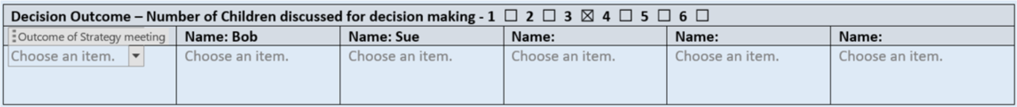
This will provide a list of outcomes, which you can select with the cursor by clicking on the relevant outcome as per the below for each child.
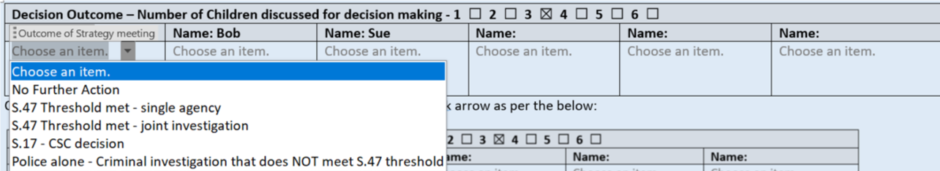
If the decision is a single agency investigation, then the following box should be completed confirming which agency will be conducting the investigation and why?
If single agency, document which agency and why?
Click here to enter text.

Agree/Disagree with the decision outcome.
This section is here to identify if there are any discrepancies between the different partner agencies in relation to the decision outcome.
If all agencies are unanimous in agreement of the decision, then click in the yes box and move to the next section.
If any of the agencies disagree with the decision, then the no box must be selected, and then complete which agency disagrees i.e., Police or Health or Children’s Social Care etc. in the section titled ‘Agency Disagreeing with decision’ then in the next box along provide a rationale as to why they disagree.
Does Do all partner agencies present agree with the decision | Yes ☐ | No ☐
Agency Disagreeing with decision | Rationale as to why they disagree
Click here to enter text. | Click here to enter text.

To ensure this is recorded accurately the agency disagreeing must complete this in the meeting chat messages section so the minute taker can cut and paste the rationale into the document. This alleviates any discrepancies or inaccurate recording.
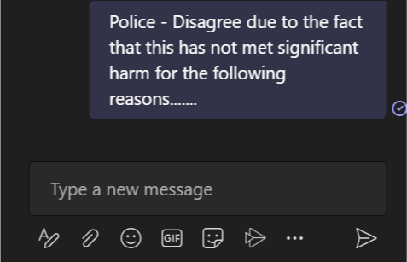
If there is more than one agency that disagrees then a new box can be added by selecting the + sign at the end of the text box ‘Rationale as to why they disagree’ as per the below:
This will create a new section as follows:
Does Do all partner agencies present agree with the decision | Yes ☐ | No ☐
Agency Disagreeing with decision | Rationale as to why they disagree
Click here to enter text. | Click here to enter text.
Click here to enter text. | Click here to enter text.

Escalation
If there is any agency that disagrees with the decision, then the following box should be completed by selecting the relevant yes box and stating which agency will be escalating, as per the below.
Escalation required | Yes ☒ No ☐
To be escalated by: | Children’s Social Care

If there is more than one agency escalating, then the box can be expanded by selecting the + symbol at the end of the box as per the below:
This would then create the new section as per the below.
Escalation required | Yes ☒ No ☐
To be escalated by: | Children’s Social Care
To be escalated by: | Click here to enter text.

Any escalations are to follow the procedures set up and agreed with each agency.

Return to the index page

Initial Investigation and safeguarding plans

This section is vital to provide a structured, detailed, and clear INITIAL investigation and safeguarding plan. Key aspects that need to be covered are:
ABE, Medicals, Forensics, Identifying the crime, Arrest strategy, Safeguarding, such as CRM scripts, target hardening, removal of the child etc.
These all need to be covered in the below section.
In relation to the medical and ABE the relevant boxes need ticking to show whether an ABE or Medical is required, once the relevant Yes/ No box has been selected then the rationale to be recorded in the main section.
Initial investigation and Safeguarding Plan
The following aspects need to be covered in the investigation plan with clear rationale.

Is a medical examination required: Yes ☐ No ☐ | Is an ABE interview required: Yes ☐ No ☐
The following areas need to be considered:

ABE
Rationale as to why or why not this is to be conducted. If it is required, ensure that the following key points are covered.
- Where is best to see the child and how this is going to be arranged for Pre ABE assessment.
- Does the child have capacity? Is an assessment required? Who is going to arrange this?
- Who is best to support the child? Who knows child best? Who is already working with the child? Who is most appropriate?
- Time frame to see the child in. Is there a best time of day? Does this need to happen today? If not, why not? Impact on investigation, memory or child?
- Who will lead the ABE Assessment? Who will record the assessment and where? Who will interview, who will control (second)
- Where is best to see the child and how this is going to be arranged for ABE.
- Travel arrangements and who is organising this. Including following the interview.
- Time frame for ABE process to be completed.
- Who will lead the ABE? Who will interview, who will control (second)
- Qualifications of Police Officers conducting ABE
- Qualifications of Social Worker conducting ABE (If not trained why are we using them? Most suitable person?)
- Any communication needs of child (is an intermediatory required)
- Any diversity needs?
- Any foreseen issues?

MEDICAL

NB if a child requires immediate medical assistance, please ensure attendance at the Emergency Department Consider seeking speciality advice from the Anlaby Suite (Mon-Fri) (Weekends and BH follow the NHSE CSAAS Pathway) Was case discussed with the Specialist Team at the Anlaby suite: Yes No

Rationale as to why or why not this is to be conducted. If it is required, ensure that the following key points are covered.
- Why is a medical required (what are we looking to gain)?
- Is the SARC in attendance, what guidance have they given?
- Is it a forensic or child protection medical?
- If formal medical not required, do we require photographs. Are this evidential? Who is taking the photographs? Are we going to complete more than one set (if injuries will become more visible)?
- Parental attendance. Who will be the appropriate adult for the child? Which is the most appropriate parent. Issues/safety planning?
- Who is the lead agency to take the child for medical?
- Who will be explaining the process to the child?
- Travel arrangements and who is organising this?
- Where will the medical be conducted?
- Time frames the medical is to be completed in. Rational for this time scale?
- Consider siblings.

Suspect Management

If there is a suspect identified provide a brief initial plan from the current information known and the risk identified from the discussion. Key points to cover.
- What criminal offence is being investigated?
- Is the suspect to be arrested or not at this stage – Rationale i.e., may be more suitable for Voluntary Interview
- If to be arrested – Provide the necessity test and any considerations for search, seizure, and forensic plan.

SAFEGUARDING
Key aspects to be covered in relation to safeguarding can come from all partner agencies with some suggestions below, however this is not an exhaustive list, and the safeguarding needs to be bespoke to that child(ren)

- What risks are present?
- What risks can be removed and how. Who is going to do this? Time scale.
- What protective factors are there at this point in time?
- What risks can be avoided and how. Who is going to do this? Time Scale
- What risk can be reduced and how. Who is going to do this? Time Scale
- What risks do we have to accept? What is the impact of this?
- Child’s capacity to be included in the safeguarding plan. In what way?
- Who are the safe adults/ others?

Safeguarding measures that may assist.

- CRM Script (Notice on Police systems. This is to provide an immediate response should a call for service come to the police and the Child’s name, address, phone number etc. shows up)
- Target Hardening – Such as window and door checks/ Panic Alarm/ CCTV/ Fireproof target harden request to the Fire Brigade
- Removal of the child for their safety – Consider PPO, Section 20, EPO etc.
- Remove the suspect (Person posing the risk) from the address
- Rapid Family Network Meeting - If immediate safety of the child is an issue, ask the family to bring a network to the office/ hospital / family hub by the end of the day.
- Education Placement – Is the child in school and what plan can be put in place to support them
- Planned direct work with the Child/Family
- Identify family solutions
- Are the parents’ protective factors

To ensure this is completed effectively the investigation plan and safeguarding plan should be written by the agencies that are involved such as Police, Children’s Social Care, Education, Health etc. utilising the Meeting Chat in teams. It is then down for each agency to cover off their specifics, for example the Police writing up the plan around the ABE:
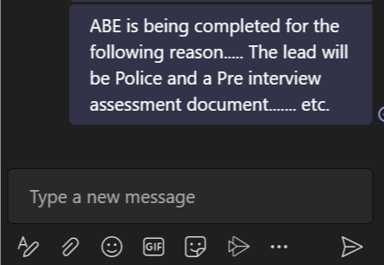

This can then be easily cut and paste into the document during the meeting.
Return to the index page

Information Sharing

This section is in relation to what information is to be shared with the Child and or family from the information shared in the discussion section and what will not be shared.

Information to share
This box should be completed where there is relevant information that should or needs to be told to the child/ family to help provide support and clarity as to why the intervention from Police and partners are involved. However, we cannot share any information that does not undermine the investigation, place the child or any other person at risk. When this section is to be completed, each agency should identify what information they can share and the rationale as per the below box:
Information to share with child and family
Information being shared | Rationale as to why the information is being shared
Click here to enter text. | Click here to enter text.

Information being shared should be a sentence that reflects the notes from the discussion section – Rationale section as to why this can be shared.

A new box needs to be created for each aspect of information being shared so it is clear to the officers/ staff conducting the visit or working with the family what exactly they can share. To create a new box right click in the box (Rationale as to why the information is being shared) where it states ‘Click here to enter text and a + sign will appear, click on the + sign and a new box will be generated.
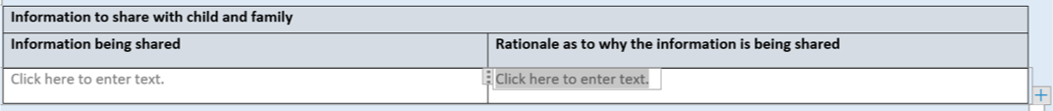

Information to share with child and family
Information being shared | Rationale as to why the information is being shared
Click here to enter text. | Click here to enter text.
Click here to enter text. | Click here to enter text.

Information NOT to be shared.

This section is equally important and must be completed by the relevant agency that does NOT want information sharing to the child and/or the family as this will fall under one of the below categories:
- 3rd Party or sensitive material
- Place’s child/ or other person at risk
- Jeopardises the police investigation

This below box should be completed where there is relevant information that should NOT be told to the child/ family.
Information NOT being shared should be a sentence that reflects the notes from the discussion section and be documented in the relevant sections below.
Information NOT being shared – This should be sentence that reflects the information from the discussion section of this document.
Criteria for not sharing – this is a drop-down list which provides the criteria.
Rationale as to why information is not being shared – This is the explanation why the child and/ or family cannot be informed.

Information NOT to share with child and family
Information NOT being shared | Criteria for not sharing | Rationale as to why information is not being shared
Click here to enter text. | Choose an item. | Click here to enter text.

A new box needs to be created for each aspect of information NOT being shared so it is clear to the officers/ staff conducting the visit or working with the family what exactly they MUST NOT share. To create a new box right click in the box (Rationale as to why the information is not being shared) where it states ‘Click here to enter text and a + sign will appear, click on the + sign and a new box will be generated.
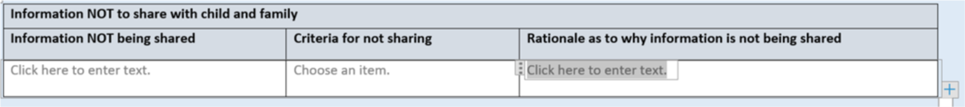

Information NOT to share with child and family
Information NOT being shared | Criteria for not sharing | Rationale as to why information is not being shared
Click here to enter text. | Choose an item. | Click here to enter text.
Click here to enter text. | Choose an item. | Click here to enter text.

To ensure these sections are completed correctly and that agency holding the information is clear as to what can be shared on not, should be typed in the meeting chat on teams as per the below:
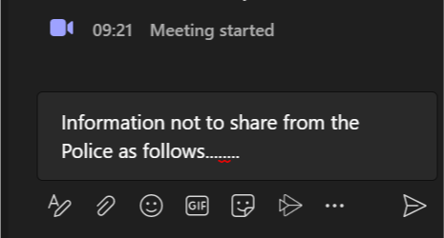 or 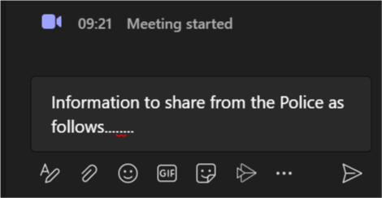

Return to the index page

Priority Actions

This section has been highlighted as an issue nationally, in that the actions from the Strategy meeting have not been identified, given ownership, or set time scales for these to be completed.
This should be completed only for the Key relevant fast time or significant priority actions, not every single action.
To assist with this the below box is to be completed and the relevant sections to be conducted.
Priority Actions
Priority | Action | Owner (Including contact details) | Time Scale
1. | ABE to be conducted | Roger.Moore@humberside.police.uk Tel 01234 567890 | Before school finishes at 15:00 hours today (05/11/12)
2. | Click here to enter text. | Click here to enter text. | Click here to enter text.
3. | Click here to enter text. | Click here to enter text. | Click here to enter text.
4. | Click here to enter text. | Click here to enter text. | Click here to enter text.
5. | Click here to enter text. | Click here to enter text. | Click here to enter text.

In relation to the action itself, this does not need to be in detail. As per the above action entry it states that the ABE is to be conducted. That will be sufficient information as the Investigation/ Safeguarding Plan section will have all the relevant detail surrounding what the plan is for the ABE, so no need to repeat this.
The owner section – Should include the persons email address and contact number (Contact Number if known) If this is unknown at the time of the strategy meeting then the supervisor for that agencies team must be placed in their as a point of contact.
Time Scale – This should be completed with a specific and relevant time frame. However, this is not always possible to be exact, so place a realistic time frame window for that action. i.e., the medical will be held in the next 72 hours due to forensic evidence but depends on the availability of the paediatrician.

If there are more than 5 priority actions and a new box is needed, then click your cursor in Time scale box where it states ‘Click here to enter text’ this will then produce a + sign that once clicked will create a new action box:
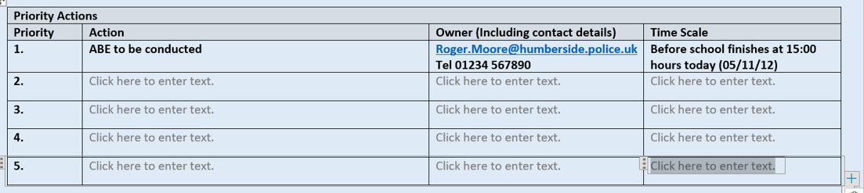

Priority Actions
Priority | Action | Owner (Including contact details) | Time Scale
1. | ABE to be conducted | Roger.Moore@humberside.police.uk Tel 01234 567890 | Before school finishes at 15:00 hours today (05/11/12)
2. | Click here to enter text. | Click here to enter text. | Click here to enter text.
3. | Click here to enter text. | Click here to enter text. | Click here to enter text.
4. | Click here to enter text. | Click here to enter text. | Click here to enter text.
5. | Click here to enter text. | Click here to enter text. | Click here to enter text.
Click here to enter text. | Click here to enter text. | Click here to enter text. | Click here to enter text.

Return to the index page

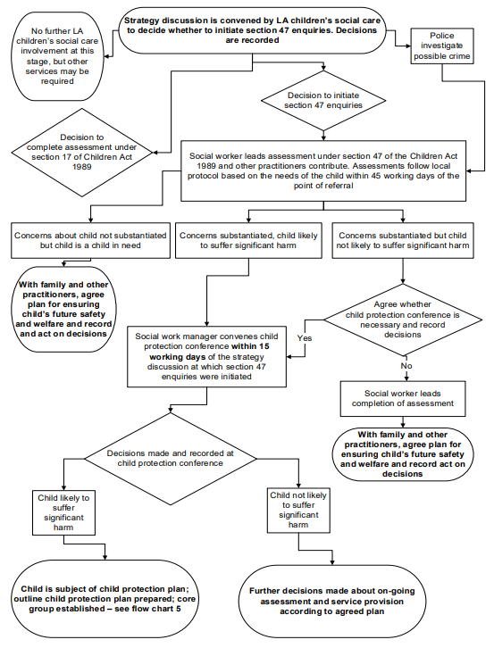

Action following a strategy discussion Flow Chart

